Turning in videos - to the network drop box

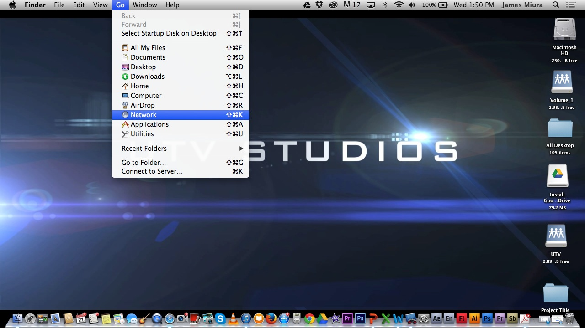

Click on the “Go” option on the top bar. If the top bar does not say go then click on an empty space on the desktop.

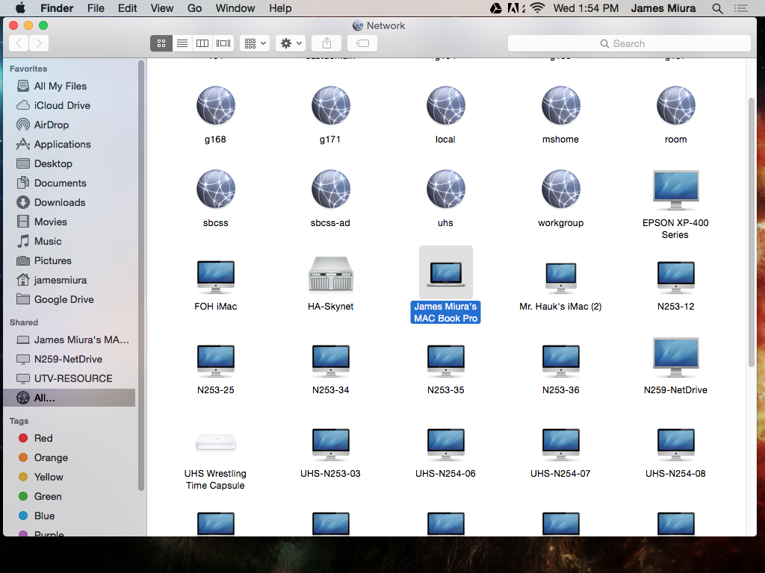

Find “James Miura’s MAC Book Pro” and click on it.

Turning in your video continued

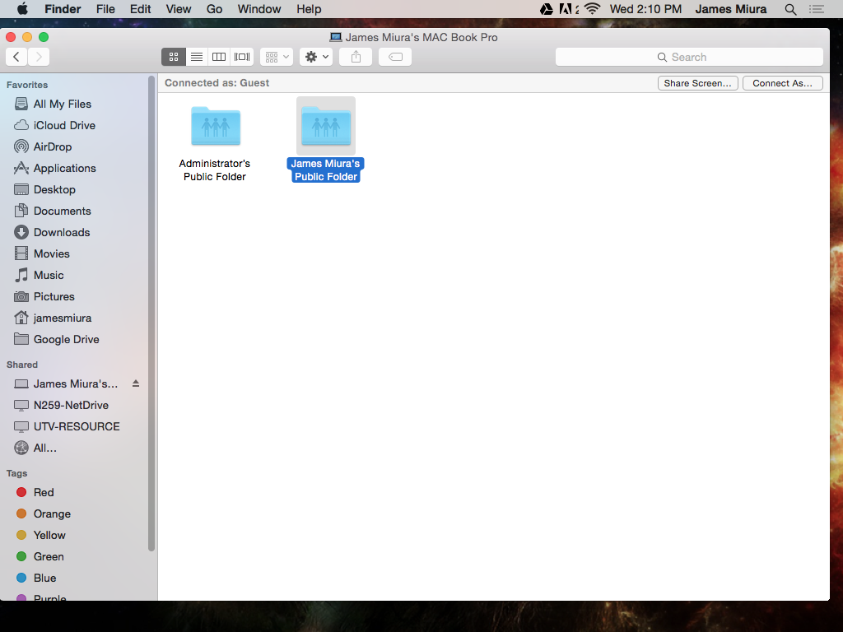

Click on “James Miura’s Public Folder”
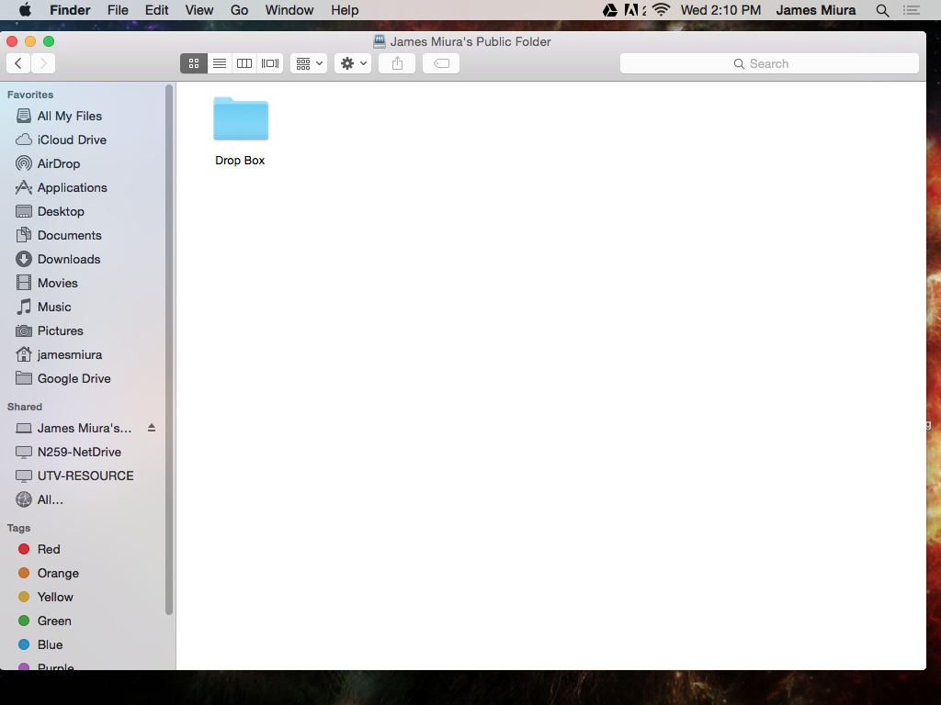

Tip: To make your icon larger and easier to drop files into, select the 1st view option.

Drag your video (not the project or xmp file) in to the “Drop Box” icon.

